**Name:** Vaishnavi Someshwar Gawande

**Roll no**: BEA 29

# Assignment No: 01

**Problem Statement**: Write a program non-recursive and recursive program to calculate Fibonacci numbers and analyse their time and space complexity.

# Code (For Non-Recursive):

n1 = int(input('Enter first number: ')) n2 = int(input('Enter second number: ')) n = int(input('Enter no. of terms: '))

print(n1,n2, end = ' ') while(n-2):

c = n1+n2 n1 = n2 n2 = c

print(c, end = ' ') n = n-1

# Input:

Enter first number: 0 Enter second number: 1 Enter no. of terms: 10

# Output:

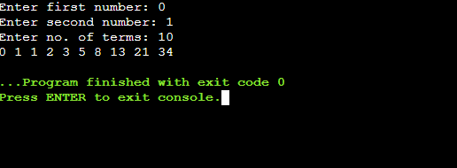

**Code (For-Recursive):**

def fibonacci(n): if n<=1:

return 1 else:

return (fibonacci(n-1)+fibonacci(n-2)) n = int(input('Enter the no. of terms: '))

for i in range(n): print(fibonacci(i), end = ' ')

# Input:

Enter the no. of terms:10

# Output:

